**NP-Complete Proof Template:**

Prove that Q is in NP-Complete

1) Show that Q ∈ NP.

Give a polynomial time algorithm that verifies an instance of Q in polynomial time. In other words if I give you an “answer” can you verify it polynomial time.

2) Show that R ≤P Q for some R∈NP-Complete

1. Pick an instance, R, of your favorite NP-Complete problem. Usually the R you select has a structure similar to Q.
2. Show a polynomial algorithm to transform R into an instance of Q.
3. Prove you are able to “solve” R by using Q. Therefore Q is as hard as R. Since R was in NP-Complete then Q must be in NP-Hard.

If both 1) and 2) are true then Q is in NP-Complete

**NP-Complete Proof - Prove** that **ALMOST-HP** is in NP-Complete

**ALMOST-HP** is the problem of, given an undirected graph with n vertices, determining if that graph has a simple path that visits at least n-1 vertices.

1) Show that **ALMOST-HP** ∈ NP.

Given a graph G with n vertices and a “purported” almost-ham path p, we can verify in polynomial time that p is a simple path in G with n-1 vertices. If p is a list of vertices we can check the adjacency lists to see if vertices are adjacent and that there are n-1 vertices.

2) Show that R ≤P **ALMOST-HP** for some R∈NP-Complete

1. Select R=**Ham-Path** because it has a similar structure to **ALMOST-HP**. We know Ham-Path is in NP.

Show that Ham-Path ≤P **ALMOST-HP**

1. Show a polynomial algorithm to transform **Ham-Path** into an instance of **ALMOST-HP**.

Given a graph G we produce a new graph G’ such that G has a Hamiltonian path if and only if G’ has an **ALMOST-HP** path. G’ is created by adding three new vertices s1, s2, and t with edges from both s1 and s2 to t and edges from t to every vertex in G. This transformation of G into G’ can be done in polynomial time by adding 3 vertices and n+2 edges.

Below is an example of the transformation.

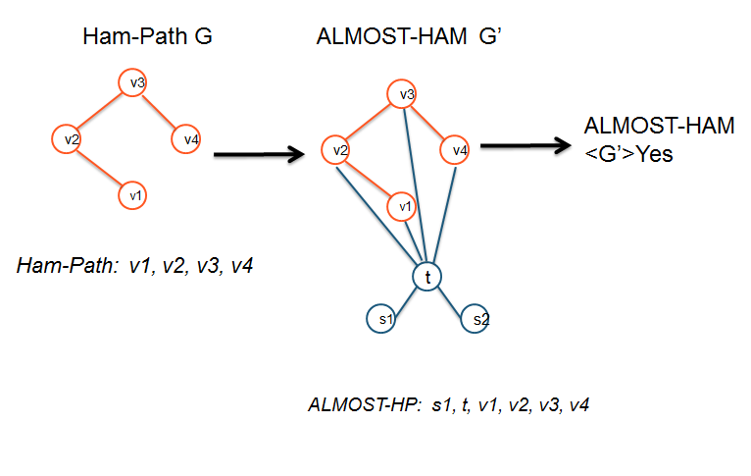

1. Prove you are able to “solve” Ham-Path by using ALMOST-HP. Therefore ALMOST-HP is as hard as Ham-Path.

Show that the graph G has a Hamiltonian-path if and only if graph G’ has an ALMOST-HP path

i) Now if G has a Hamiltonian path v1, …, vn. G’ has an almost-HP path: s1, t, v1, …, vn.

ii) If G’ has an almost-Hamiltonian path then one of the endpoints must be either s1 or s2, and the next vertex must be t and the path must then go into G, **skipping s2 or s1** (the one not already visited). Since we already have one vertex skipped, the rest of the path must visit all the vertices in G, so removing the first two edges from it produces a Hamiltonian path in G.

1. Since Ham-Path is in NP-Complete then **ALMOST-HP** must be in NP-Hard.

**Since 1) and 2) are true. ALMOST-HP is NP-Complete**